Good and bad design practices of similar web user interfaces

Tomasz Garyga

# [www.cinema-city.pl](http://www.cinema-city.pl)

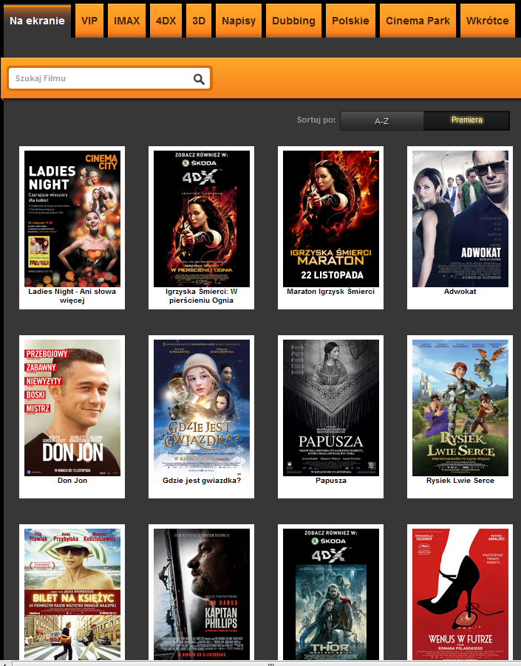

Figure

This website is example of Polish cinema website where user can check what is played and also can book or buy a tickets to the cinema.

First of all there can be recognized some interesting (and IMO good) features. Every movie is shown as picture of the movie poster with label below. This type of exposition is clear and easy to understand. Second good things is fact that above the tabs are available. Using this tabs, user can choose if want see all movies or only some types of movies (e.g. only 3D, only Polish movies, movies with dubbing, etc.).

On this website user also can search movies using search tool. Good thing connected with this search tool is fact that it gives some tips when user start write (figure 2). User can choose which order he prefers: alphabetic or according to age of movies (newest as the first).

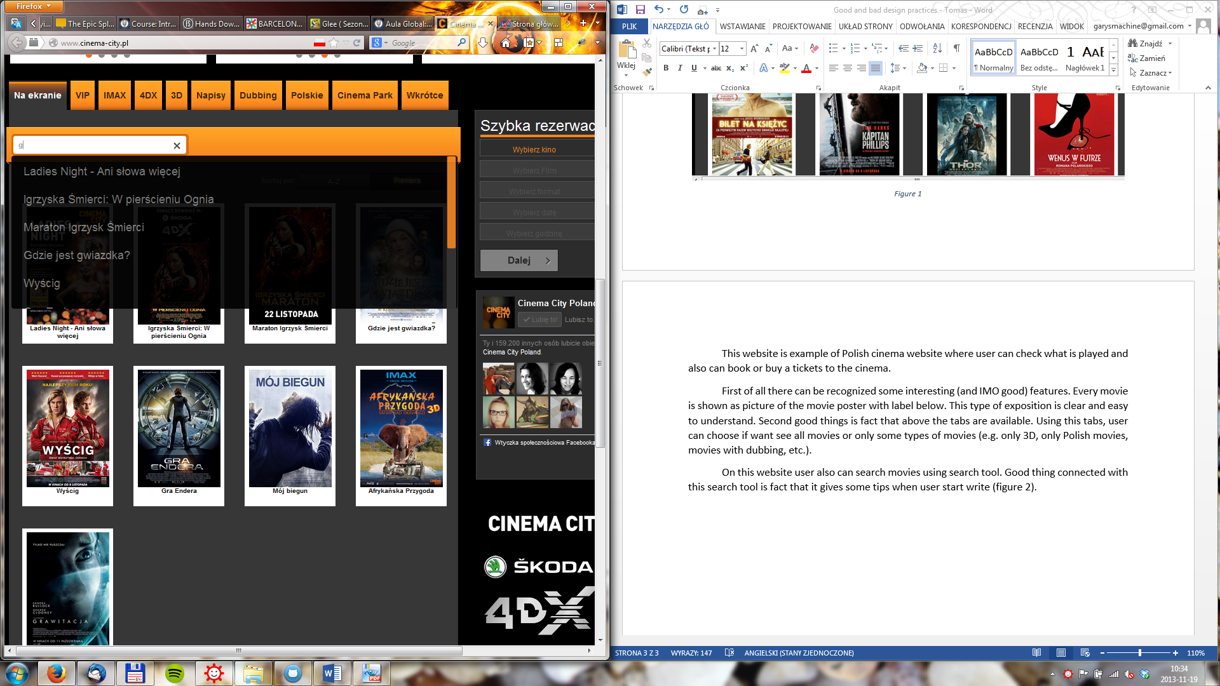

Figure

When user choose movie, the additional screen is shown (figure 3). On this site the basic information about movie are available, like title, type, director etc. Also the description of the movie is shown. Normally user can click on the poster of the movie. This action obtain play the trailer of the movie in the same screen (figure 4). The first **bad thing** is recognized here. When trailer is played the bottom “return” isn’t visible enough because movie window covers it.

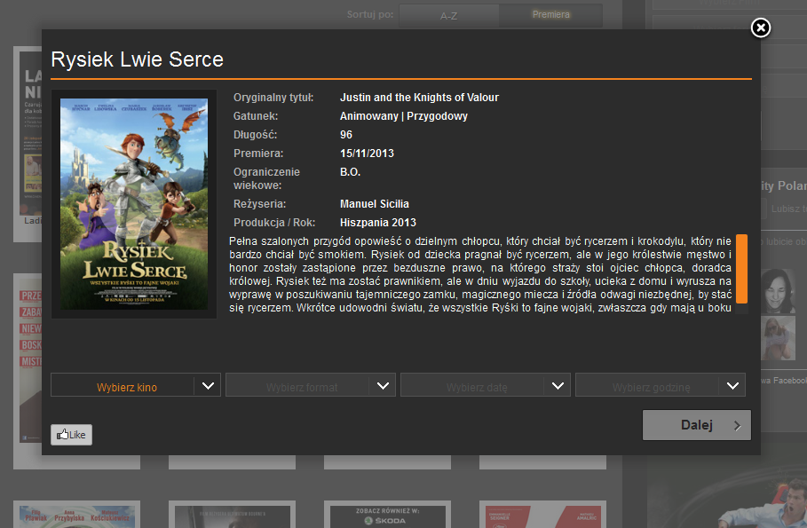

Figure

On the screen with description of movie (figure 3) user has simply form which can use when want to buy a ticket. There is observed next **bad practice**. The user isn’t informed that he can use this form to buy tickets.

In this form user firstly can choose the cinema (this website is only about one cinema company so it doesn’t have all cinemas in some area). After, user can choose what type of movie he want to see (if any types are available, e.g. 2D, 3D, dubbing, subtitles). After he choose date and hour.

When user fill form he can decided if he want to only book or buy tickets. After choose one of the option user needs to accept conditions and rules of the cinema. One of the last steps is choose how many (and what type: for adults, children, students) tickets user want to buys/books and numbers of the sits (figure 5).

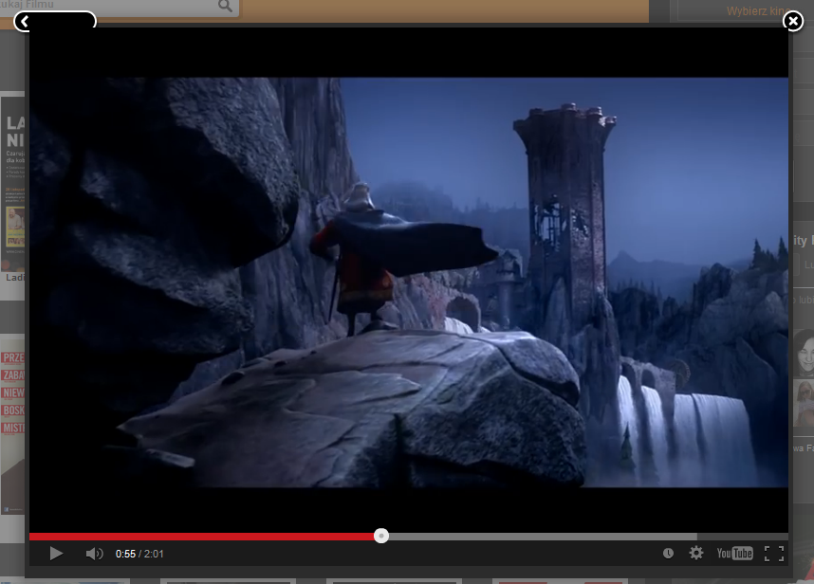

Figure

When user finished all steps he need only fill the form about his data (name, surname, email address and phone number).

Whole process is very linear and user shouldn’t have any problems with forms and this process.

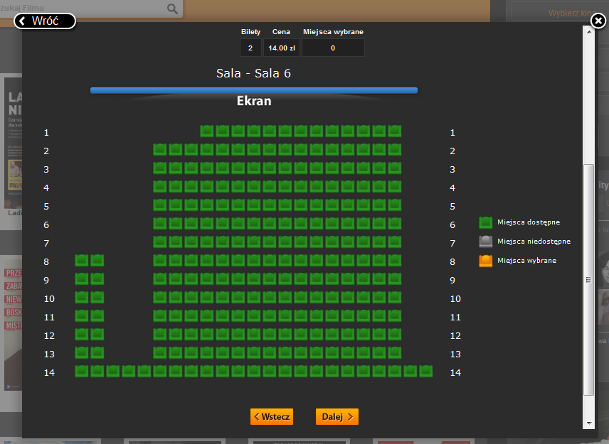

Figure